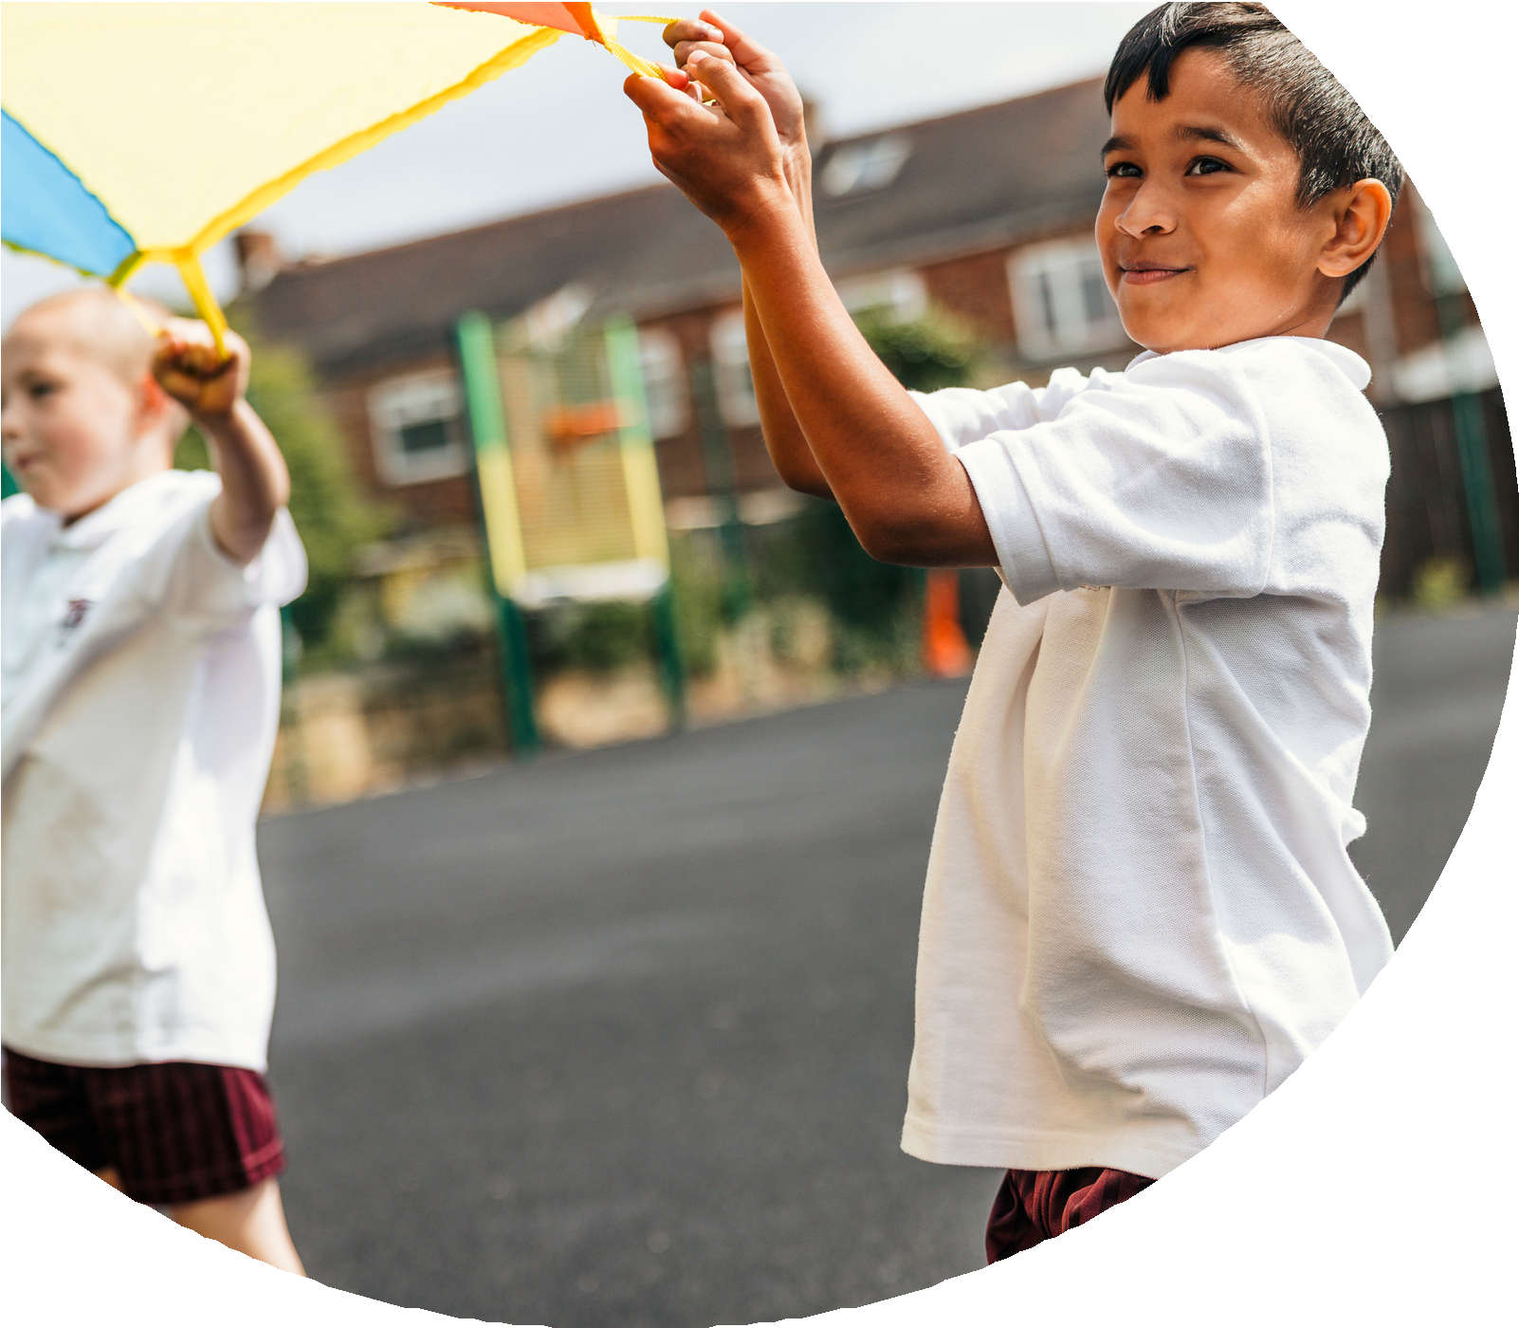
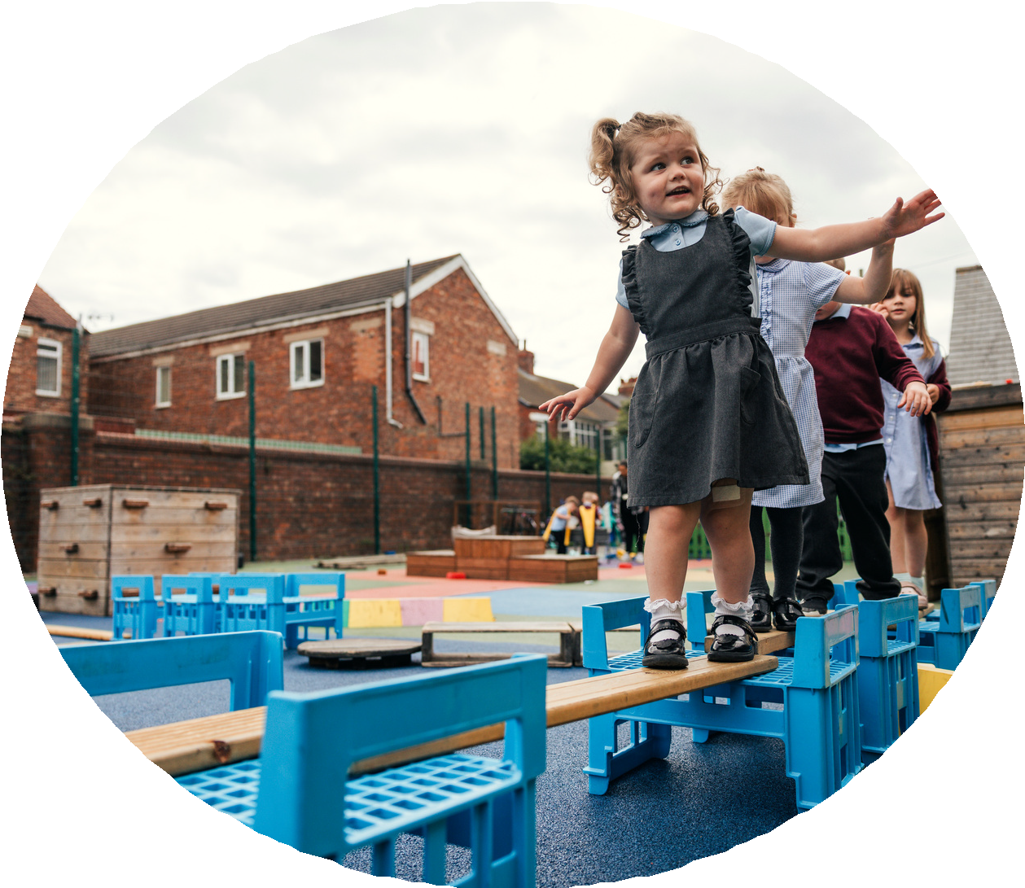

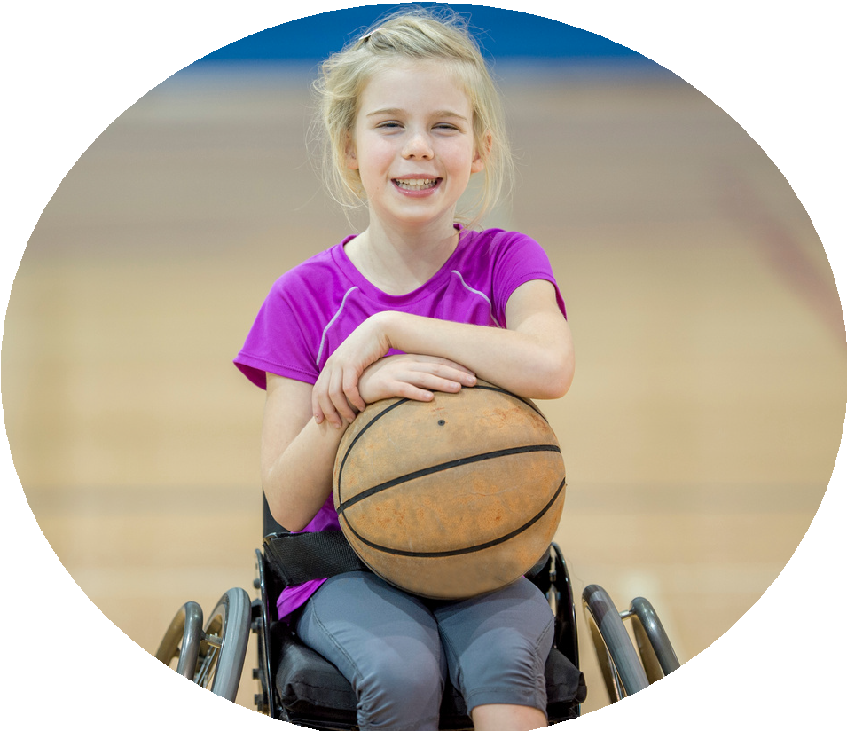



PE and sport premium monitoring and tracking form 2025/2026

Commissioned by

Crea

Useful Links:
- Complete the PE and sport premium expenditure reporting return - GOV.UK
- PE and sport premium for primary schools - GOV.UK
- PE and sport premium: conditions of grant 2024 to 2025 - GOV.UK

- It is intended that this template should be used as preparation for the completion of the statutory DfE PE and sport premium digital expenditure reporting return. You can upload data (including swimming) from this template onto this platform once it becomes accessible.
- The template is a working document that you can amend and update during the year.
- Before you decide how you are going to use the funding for this academic year you should reflect and evaluate the impact of your use of you PE and sport premium funding in 2024/25.
- You should use your evaluation of last year’s funding to help you decide what to do this academic year, how you will do it, and what impact you expect it to have.
- All spending of the funding must conform with the terms outlined in the conditions of grant
- The summative digital expenditure reporting from June 2026 will continue to include swimming and water safety information. PE and sport premium funding can be used to provide top-up lessons, where necessary, to ensure pupils meet national curriculum swimming requirements
- To ensure funding is used effectively and based on your school’s needs; guidance and examples of best practice across schools can be found here.
- You must use the funding to make additional and sustainable improvements to the PE and sport in your school.
- You must develop and add to the PESSPA activities that your school already offers.

Useful Links:
Complete the PE and sport premium expenditure reporting return - GOV.UK
PE and sport premium for primary schools - GOV.UK
PE and sport premium: conditions of grant 2024 to 2025 - GOV.UK


Review of the last academic year (2024/2025)
Swimming and Water Safety | What went well? Supporting evidence? | What didn't go well? Supporting evidence?
1. Swim competently, confidently and proficiently over a distance of at least 25 metres | A significant proportion of pupils successfully achieved the target, with 86% passing and demonstrating the ability to swim competently, confidently, and proficiently over a distance of at least 25 metres. Many pupils showed clear improvements in their technique, water confidence, and stamina. The structured swimming lessons, supported by skilled instructors and appropriate resources, allowed pupils to progress effectively, and those who were less confident benefited from additional targeted support. Overall, this reflects a strong impact of the swimming program on pupils’ physical development and water safety skills. | Follow up lessons were promoted but not always taken advantage of by parents/carers.
2. Use a range of strokes effectively (for example, front crawl, backstroke and breaststroke) | Many pupils were able to use a range of strokes effectively, including front crawl, backstroke, and breaststroke. Progress was evident in both technique and confidence in the water, with pupils demonstrating greater control, coordination, and endurance. Differentiated teaching and targeted support helped less confident swimmers improve, while more advanced swimmers were challenged to refine their stroke technique. Overall, the swimming program successfully developed pupils’ skills across multiple strokes, supporting both competence and confidence in the water.
3. Perform safe self-rescue in different water-based situations | These areas were covered in the PE lessons delivered by SC.  Swimming teacher demonstrated and gave all pupils the opportunity to practise on ne than one occasion.

Key areas as outlined in PE and sport premium guidance | What went well? Supporting evidence? | What didn't go well? Supporting evidence?
1. Increasing confidence, knowledge and skills of all staff in teaching PE and sporting activities prioritising CPD and training where needed | This year, staff confidence and competence in delivering high-quality PE lessons improved significantly through targeted CPD and specialist training. Teachers accessed workshops focused on inclusive practice, progressive skill development, and innovative lesson planning. As a result, PE lessons are now more structured, engaging, and aligned with national standards, ensuring pupils receive consistent, high-quality physical education.  All staff have access to high quality curriculum planning. | Despite improvements, not all staff were able to access the full range of CPD opportunities due to timetable pressures and conflicting commitments. This led to inconsistencies in staff confidence levels, particularly in less familiar sports and activities
2. Increasing engagement of all pupils in regular physical activity and sporting activities | Pupil engagement in physical activity increased, with more children participating in daily movement and structured sport. Lunchtime and after-school opportunities expanded, supported by new equipment that encourages active play and fitness. These resources promote long-term health benefits, fostering habits that extend beyond the school day. The increased activity levels have contributed to improved focus and wellbeing across the school. | Although overall engagement increased, a small number of pupils were still reluctant to take part in regular physical activity. Some of the planned activities did not appeal equally to all groups, particularly those who lacked confidence or had lower baseline fitness levels. Weather and timetable disruptions also meant that certain initiatives—such as outdoor clubs and daily activity sessions—were not delivered as consistently as intended. In addition, communication with families about the importance of regular physical activity was not always as effective as it could have been, which limited uptake for some extracurricular opportunities. These factors meant that engagement was not fully maximised across all pupil groups.
3. Raising the profile of PE and sport across the school, to support whole school improvement | Through a series of targeted actions, the profile of PE and sport has been significantly raised across the whole school. Increased participation in a broad range of sports has encouraged more pupils to become active, confident, and engaged in healthy lifestyles. The installation of new, high-quality equipment has provided long-lasting health benefits for our children and created exciting opportunities for both structured lessons and independent play. In addition, the quality of PE teaching has improved through focused CPD and staff training, ensuring lessons are more dynamic, inclusive, and effective. Collectively, these developments have supported whole-school improvement by boosting pupil wellbeing, enhancing behaviour, and embedding a positive culture of physical activity throughout the curriculum. | A few planned events and celebrations of sport had to be scaled back or postponed due to staffing, scheduling pressures, or weather disruptions, which limited their overall impact. Additionally, communication of PE successes was not always regular—meaning some achievements were not shared widely enough to reinforce the importance of physical activity across the whole school.
4. Offer a broader and more equal experience of a range of sports and physical activities to all pupils and ensure equal access to sport for boys and girls | We broadened our sports offer to include a diverse range of activities, ensuring equal access for all pupils, regardless of gender or ability. New equipment enabled the introduction of more structured sports and activities at playtimes, lunchtimes and during lessons, giving children more choice and opportunities to discover activities they enjoy. This inclusive approach has helped reduce barriers and increase participation among previously less active groups. | Transport, scheduling, and space constraints also restricted how many sports could be delivered at once, resulting in fewer options than planned. These challenges meant that, although progress was made, a fully equal and diverse sporting offer was not achieved for all pupils. Despite efforts to broaden the range of sports and ensure equal access for all pupils, some activities were still more popular with certain groups, leading to imbalances in participation
5. Increasing participation in competitive sport | Competitive sport participation grew significantly, with more pupils representing the school in inter-school and intra-school events. Enhanced provision and improved confidence from high-quality PE lessons have encouraged pupils to take part in competitions. | Although participation in competitive sport increased, several challenges limited the overall impact. Transport issues were a recurring barrier, with difficulties securing minibuses and drivers resulting in late arrivals, reduced team numbers, or, in some cases, the cancellation of fixtures. These disruptions affected pupils’ consistency and confidence in taking part. Additionally, fixture schedules often clashed with other school commitments, meaning not all pupils who wanted to compete were able to do so. Some competitions also required additional staffing that was not always available, further limiting participation. As a result, while progress was made, the full range of competitive opportunities could not be accessed as planned.

Aims for the next academic year (2025/2026)
- 5 key areas improvements will be focussing on:
- Increasing confidence, knowledge and skills of all staff in teaching PE and sporting activities prioritising CPD and training where needed.
- Increasing engagement of all pupils in regular physical activity and sporting activities
- Raising the profile of PE and sport across the school, to support whole school improvement
- Offer a broader and more equal experience of a range of sports and physical activities to all pupils and ensure equal access to sport for boys and girls
- Increasing participation in competitive sport
Swimming and Water Safety | Input data | Reflections
1. Swim competently, confidently and proficiently over a distance  of at least 25 metres | 86%
2. Use a range of strokes effectively
(for example, front crawl, backstroke and breaststroke)
3. Perform safe self-rescue in different water-based situations

Aim | Why? | Key area | Supporting evidence
Ensure all teaching staff have the confidence, skills, and knowledge to deliver high-quality PE lessons, including differentiation for SEND pupils and engagement of inactive girls. | Staff confidence directly affects the quality of PE lessons, pupil engagement, and skill progression. Targeted CPD ensures consistency in lesson delivery and enables all pupils to access high-quality physical education. | Increasing confidence, knowledge, and skills of all staff in teaching PE and sporting activities. | Staff audit highlights areas of lower confidence, particularly in unfamiliar sports.  Lesson observations and feedback indicate variability in PE delivery.  CPD and mentoring programs have improved staff skills in previous years but further development is needed.
Achieve at least 90% pupil participation in regular physical activity each week, with a focus on inactive girls, SEND pupils, and disadvantaged pupils. | Regular physical activity supports health, wellbeing, behaviour, and learning outcomes. Certain groups (inactive girls, SEND, disadvantaged pupils) are at higher risk of low participation and require targeted strategies to engage them. | Increasing engagement of all pupils in regular physical activity and sporting activities. | Previous participation data shows lower engagement among specific pupil groups.  Pupil surveys indicate enthusiasm for physical activity but barriers exist for some groups.  Extracurricular attendance records reveal opportunities to increase participation.
Make PE and sport visible, celebrated, and central to school culture, ensuring every pupil experiences recognition of achievements. | Raising the profile increases motivation, encourages engagement in physical activity, and reinforces the school’s commitment to health and wellbeing. | Raising the profile of PE and sport to support whole-school improvement. | Displays, newsletters, and social media posts demonstrate some recognition of sporting achievements, but this is inconsistent.  Whole-school events like sports days increase participation but require further development to embed culture.  Positive pupil feedback on recognition correlates with increased engagement.
Ensure all pupils have access to a wide range of sports and activities, promoting equality of access between boys and girls, SEND pupils, and disadvantaged pupils. | Diverse sporting opportunities encourage lifelong participation, increase pupil confidence, and ensure fairness in access to physical education. | Offering a broader and more equal experience of sports and physical activities. | Participation data shows some activities are dominated by specific pupil groups.  Pupil voice indicates interest in trying new sports and activities.  Previous monitoring demonstrates gaps in access for girls, SEND pupils, and disadvantaged pupils.
Ensure all pupils have the opportunity to compete at least once per term, with sufficient support for transport, staffing, and inclusive participation. | Competitive sport develops teamwork, resilience, and confidence. Ensuring access for all pupils, including SEND and disadvantaged pupils, increases engagement and enjoyment. | Increasing participation in competitive sport. | Previous years’ records indicate transport and staffing issues limited participation.  Participation data shows some pupils rarely experience competitive opportunities.  Feedback from pupils and staff highlights enthusiasm for competitions when available.
Ensure 90%+ of pupils can swim competently, confidently, and proficiently over 25 metres, and use multiple strokes effectively (front crawl, backstroke, breaststroke). | Swimming is a key life skill that supports safety, fitness, and confidence in the water. Targeted support ensures all pupils, including SEND and less confident swimmers, meet national expectations. | PE curriculum – swimming. | 86% of pupils currently meet the 25-metre standard.  Observations show pupils using multiple strokes effectively.  Booster sessions and small-group teaching have successfully improved outcomes in previous years.

Plan, monitor and evaluate (2025/2026)
- Please aim to use this as a live working document through the year.

- Keep returning to this to evidence adaptations and progress made through the PESSPA opportunities you provide.

- There is no set number of objectives you must have.

- Make as many or as few as you see fit that will support your aims for the year ahead.

- Consider which of the 5 key areas improvements will be focussing on:
- Increasing confidence, knowledge and skills of all staff in teaching PE and sporting activities prioritising CPD and training where needed.
- Increasing engagement of all pupils in regular physical activity and sporting activities
- Raising the profile of PE and sport across the school, to support whole school improvement
- Offer a broader and more equal experience of a range of sports and physical activities to all pupils and ensure equal access to sport for boys and girls
- Increasing participation in competitive sport

Plan, monitor and evaluate (2025/2026)

Your Objective:

 | Intent – what is your objective? | Implementation - How will you achieve this? | Impact - What do you hope to see? | Supporting evidence
Plan and monitor
 | What impact have you seen? | Are the improvements sustainable? How? | Supporting evidence | Approx. cost
Evaluate

Your Objective:

 | Intent – what is your objective? | Implementation - How will you achieve this? | Impact - What do you hope to see? | Supporting evidence
Plan and monitor

 | What impact have you seen? | Are the improvements sustainable? How? | Supporting evidence | Approx. cost
Evaluate

Your Objective:
 | Intent – what is your objective? | Implementation - How will you achieve this? | Impact - What do you hope to see? | Supporting evidence
Plan and monitor

 | What impact have you seen? | Are the improvements sustainable? How? | Supporting evidence | Approx. cost
Evaluate

Your Objective:
 | Intent – what is your objective? | Implementation - How will you achieve this? | Impact - What do you hope to see? | Supporting evidence
Plan and monitor

 | What impact have you seen? | Are the improvements sustainable? How? | Supporting evidence | Approx. cost
Evaluate

Your Objective:

 | Intent – what is your objective? | Implementation - How will you achieve this? | Impact - What do you hope to see? | Supporting evidence
Plan and monitor

 | What impact have you seen? | Are the improvements sustainable? How? | Supporting evidence | Approx. cost
Evaluate

This page has been left blank for any notes or supporting information.

