FORM C1

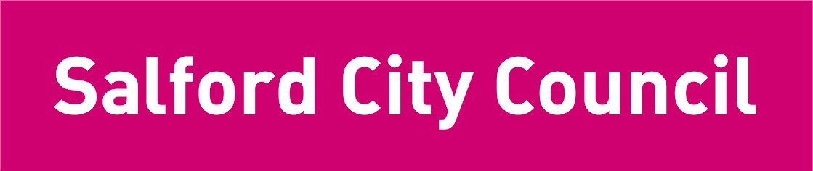

Parental Consent Form
Regular out-of-establishment visits / activities

Name of School:

For journeys away from the school lasting up to one day without overnight stay.

To the Headteacher,

I am willing to allow my son/daughter* date of birth
to take part in activities away from the school base during the period 1st September 2020 to 31st July 2021, and for the form teacher, teacher in charge or Headteacher to sign on my behalf any forms of consent required by the hospital authorities in the event on my son/daughter* being ill or injured during the course of the journey or stay to the extent that a surgical operation or serum injection becomes necessary, provided the delay required to obtain my own signature might be considered likely in the opinion of the doctor or surgeon concerned to endanger my son’s/daughter’s* health or safety.

All pupils are covered by the City Council’s third party liability insurance in respect of any claim arising from an accident caused by a defect in the school premises or equipment or attributable to negligence by the City Council or one of their employees. These arrangements do not provide personal accident cover.

Signed: Parent/Guardian ____

Address:

Tel No: Home Mobile Work

If not available at above, please contact:

Name: Tel No:

Address:

Name, Address and
telephone number of
family Doctor:

