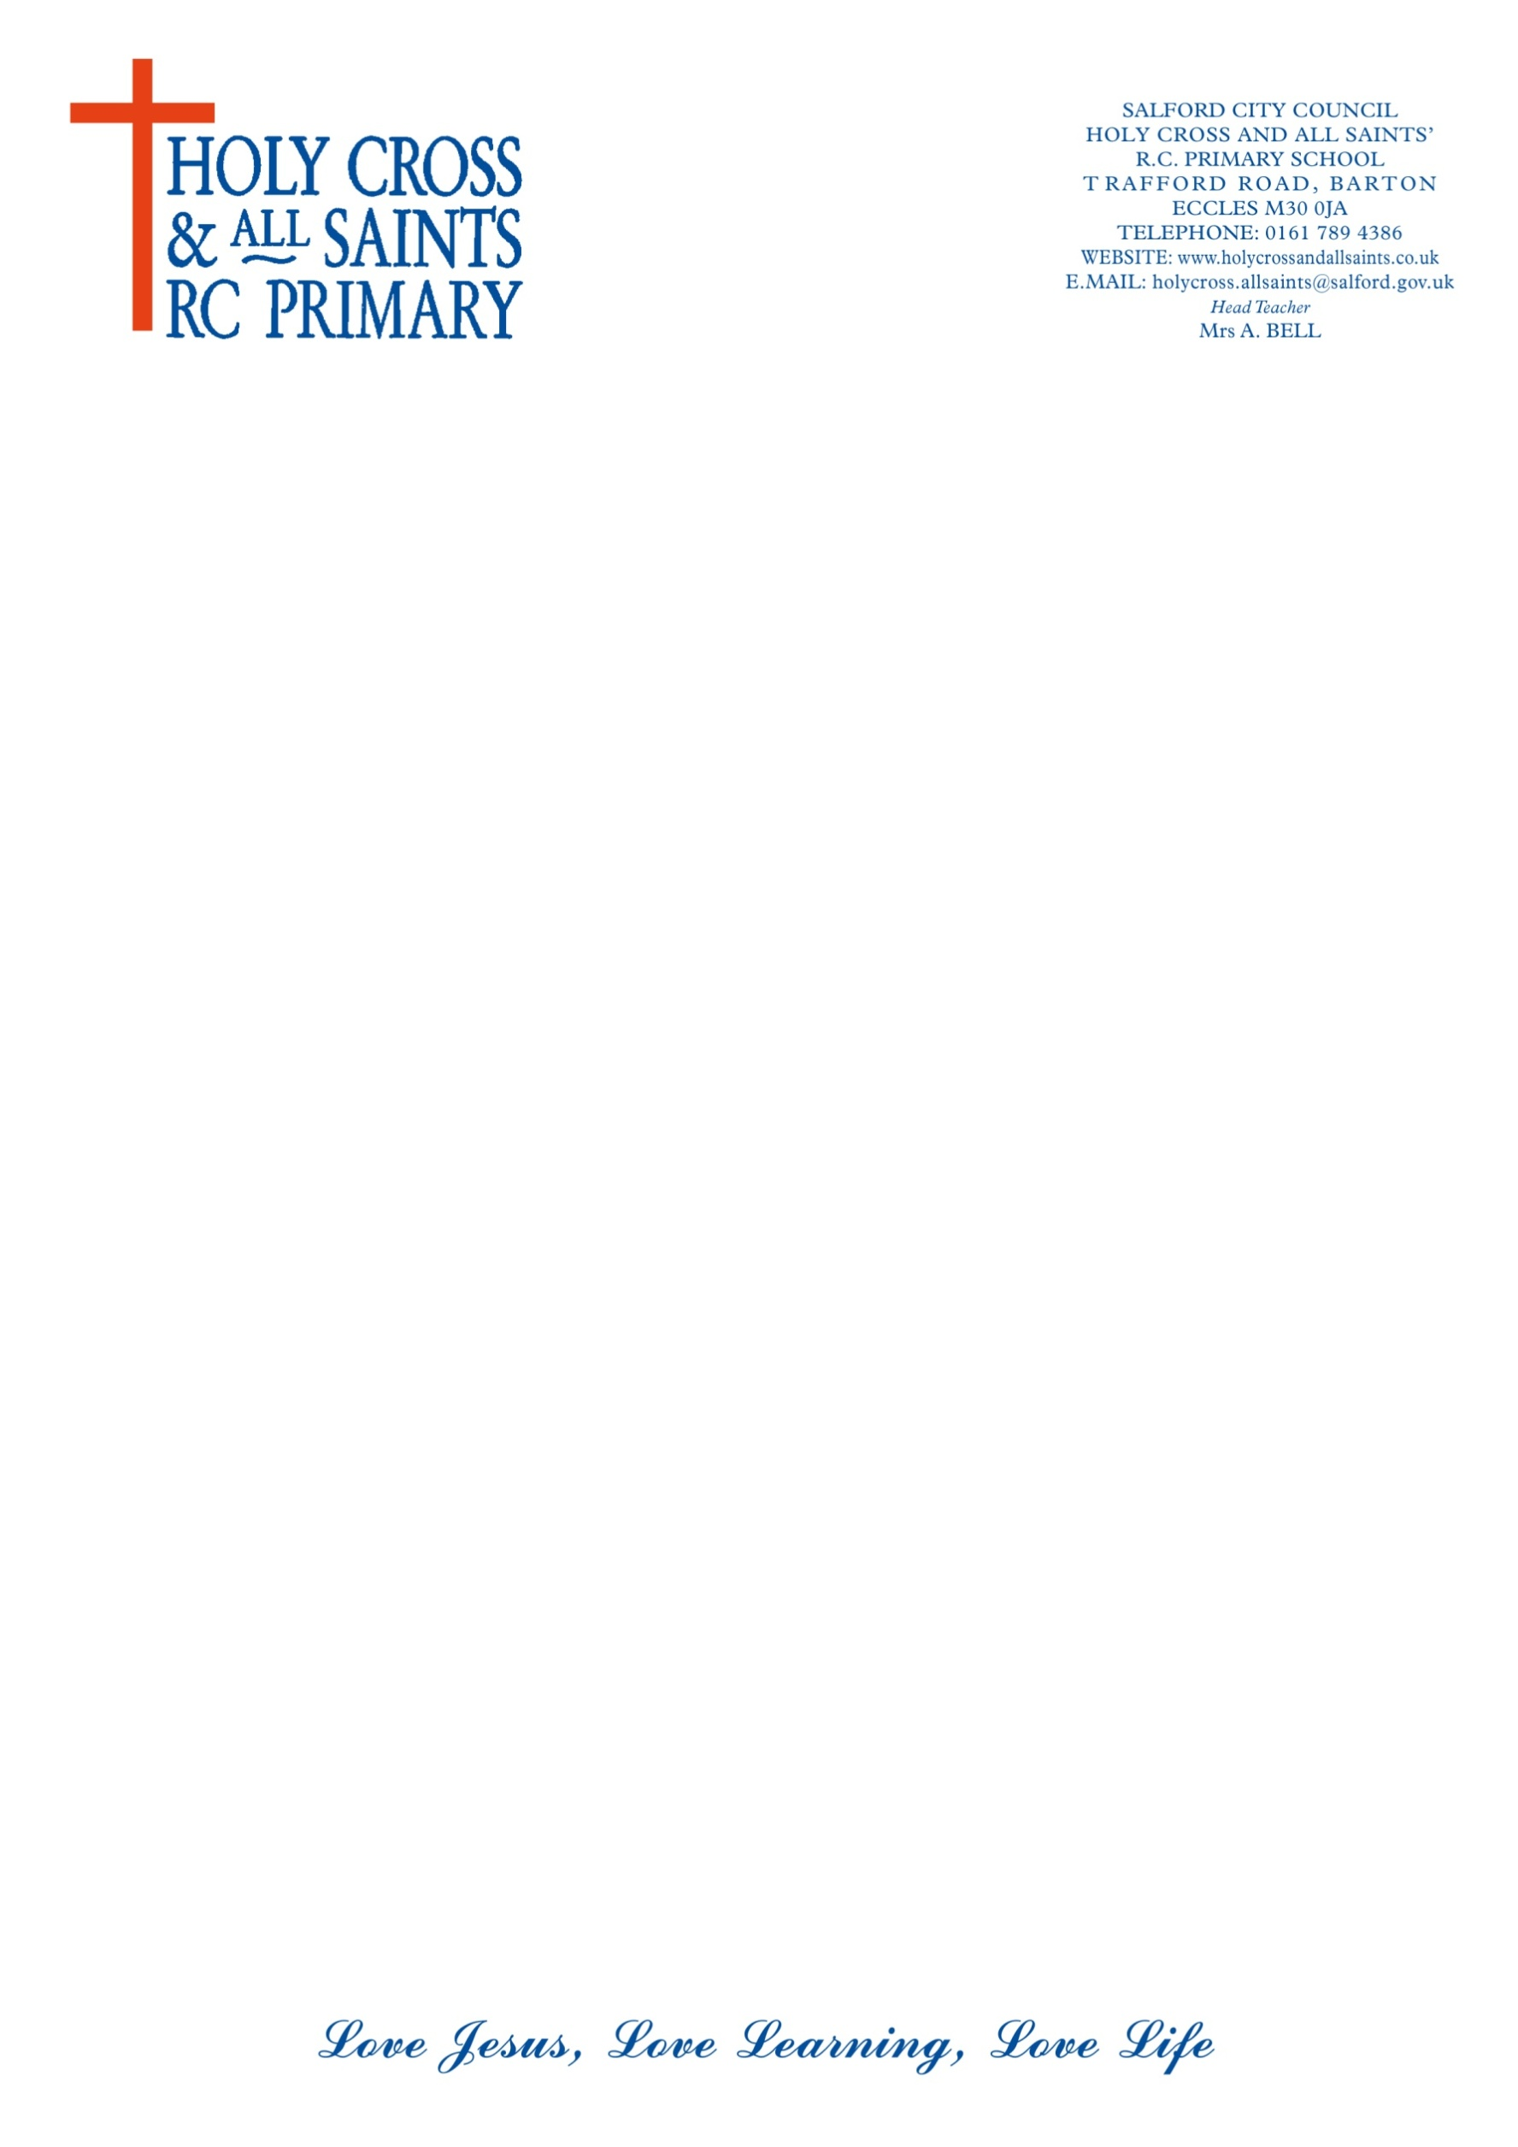

**CONSENT FORM FOR PERSONAL DATA**

Your privacy is important to us, and we want to communicate with our Staff, Governors, Parents and our Children in a way which has their consent, and which is in line with UK law on data protection. As a result of a change in UK law in May 2018, we need your consent to how we contact you. Please fill in the contact details you want us to use to communicate with you:

Name: **____________________________________________________________**

Address: **__________________________________________________________**

**__________________________________________________________**

Email Address: **_____________________________________________________**

Phone Number: **Home______________________Mobile_____________________**

By signing this form you are confirming that you are consenting to **Holy Cross and All Saints RC Primary School** holding and processing your personal data for the following purposes (please tick the boxes where you grant consent):-

I consent to **Holy Cross and All Saints RC Primary School** contacting me by

🞏 post 🞏 phone/text 🞏email.

☐ To keep me informed about news, events and activities at **Holy Cross and All Saints RC Primary School** *(note you can unsubscribe from the school newsletter at any time)*;

Parental Responsibility for (please name your children in our school):

1)----------------------------------------------------------------------------------------

2)----------------------------------------------------------------------------------------

3)----------------------------------------------------------------------------------------

4)----------------------------------------------------------------------------------------

5)----------------------------------------------------------------------------------------

Signed: **____________________** Dated: **_________________**

Where you do not grant consent we will not be able to use your personal data; (so for example we may not be able to let you know about forthcoming events); except in certain limited situations, such as where required to do so by law or to protect members of the public from serious harm. You can find out more about how we use your data from our “Privacy Notice” which is available from our website.

You can withdraw or change your consent at any time by contacting Mrs Jackson in the school office. Please note that all processing of your personal data will cease once you have withdrawn consent, other than where this is required by law, but this will not affect any personal data that has already been processed prior to this point.