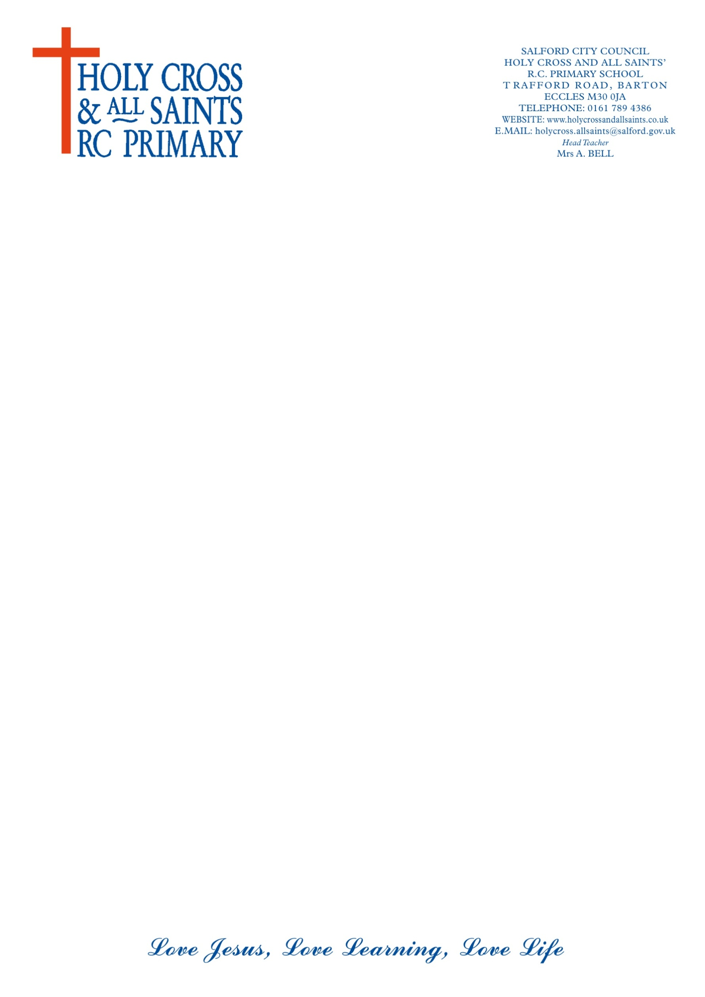

ALLERGIES FORM

Child’s name ……………………………………………………………………………..

Date of birth ………………………………………………………………………………

Home address ……………………………………………………………………………

………………………………………………………………………………………………

Telephone number ………………………………………………………………………

Contact address if different from above ……………………………………………….

………………………………………………………………………………………………..

Family doctor’s name and address ……………………………………………………….

…………………………………………………………………………………………………

Telephone number ………………………………………………………………………….

Does your child have any allergies? (e.g. penicillin) …………………………………….

Does your child require any treatment for this condition?

………………………………………………………………………………………………….

Signed ………………………………………………… Parent/Guardian

Date …………………………………………..............